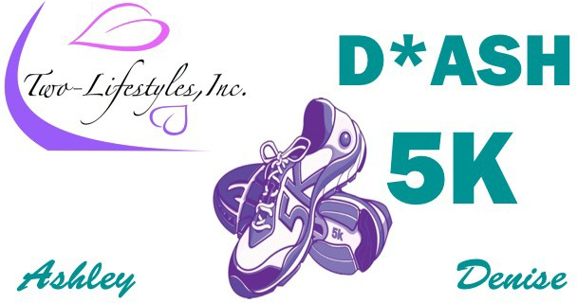
9th Annual 5K AWARENESS WALK/RUN

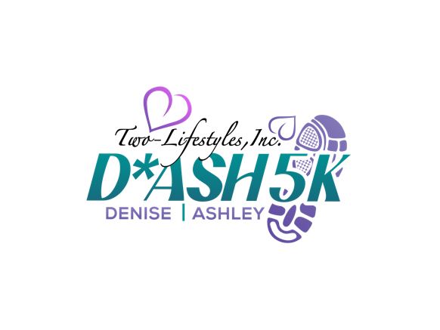

SEXUAL ASSAULT & DOMESTIC VIOLENCE
Saturday, April 6, 2024, 8:00 am-1:00 pm Two-Lifestyles, Inc.
1224 E. Avenue S, Palmdale, CA (661) 402-3076 / www.twolifestyles.org

VENDOR REGISTRATION AND AGREEMENT FORM
Organization/Company Name:
Primary Contact Person Name:
Title of Display:
Mailing Address:
Phone Number: | Cell Phone Number: |  |  | Fax Number:
E-mail: |  | Website URL:
Non-Refund Initial : _ |  |  | Title:
Authorized Signature: |  |  | Date:
Amount Paid: |  |  | Staff Included:
Selection Process – Selection of vendor displays will be based on relevance to the theme of the Event and date of receipt of the completed Vendor Registration and Vendor Agreement Forms.

Cancellation Policy – Vendor display fee is non-refundable. A 100 percent cancellation fee will be charged for this event.

Inquiries – For inquiries regarding payment Contact us, at 661-402-3076 registration@twolifestyles.org

VENDOR AGREEMENT
Management Rights: Management reserves the right to restrict exhibits that become objectionable because of noise, method of operation, materials, or, in general, detracts from the general character of the WALK

Care of Building and Equipment: Vendors or their representatives must not injure or deface the walls of the building, the displays, or the equipment of the display. If such damage occurs, the exhibitor is liable to the owner of the property damaged. All materials used in the decoration must be flameproof.

Use of Space: All demonstrations or other promotional material or activities must be confined to the limits of the exhibit booth.

Security: The vendor is solely responsible for his/her own exhibit material and should insure against loss or damage. Two-Lifestyles, Inc. is not responsible for such loss or damage. Please secure all items of value. All property of the vendor is understood to remain in his/her care, custody and control in transit to and from, and

within the confines of the exhibit area.
Please return this Vendor Registration and Agreement Form to:
Two-Lifestyles, Inc.
1224 East Ave S, Suite C Palmdale, CA 93550 or Fax 661-402-3075

